Example Capstone Planning Document

## Description:

For my Capstone Project, I will be building an interactive simulation of the Mother Goose Story, Humpty Dumpty. For reference, here is the complete story:

*Humpty Dumpty sat on a wall*

*Humpty Dumpty had a great fall*

*All the King’s horses and all the King’s men*

*Couldn’t put Humpty Dumpty back together again*

To begin the experience, viewers will see a giant wall and when they look up, they will see Humpty on top of it rocking back and forth. Around the scene, they will see some guards moving around and trees flowing with the wind.

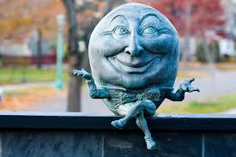

When viewers interact with Humpty, it will cause him to fall of the and when the viewers cries for help, the King’s army will arrive. The user attempts to put him back together but there will be too many pieces. The experience fades to black and it restarts.

## Features And Dependencies:

### 3D Models + Animations (Reference Images)

* 1. Humpty Dumpty model and animation
     1. 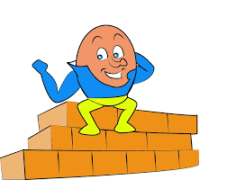
     2. 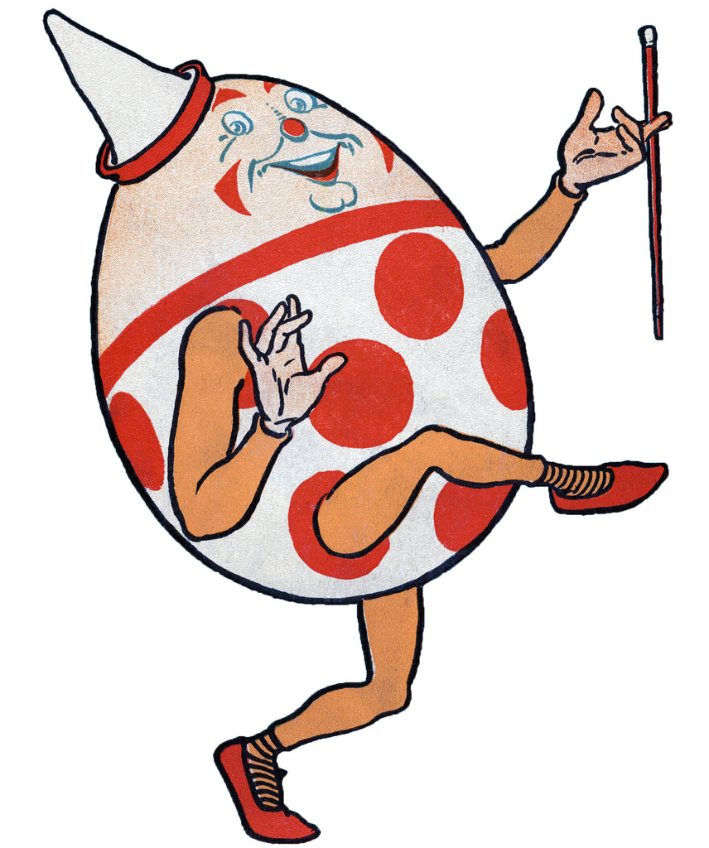
  2. King’s army soldier
     1. 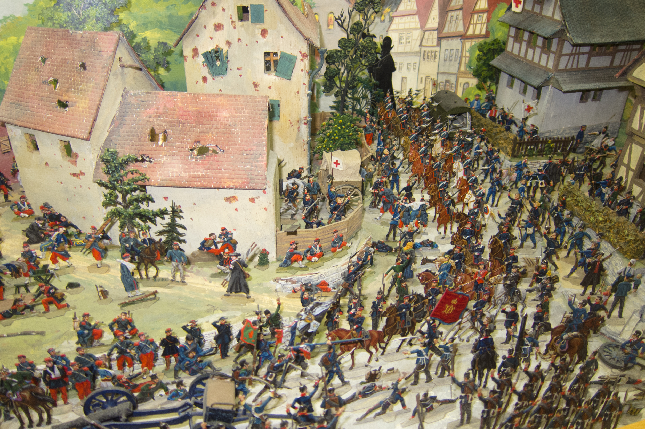
     2. 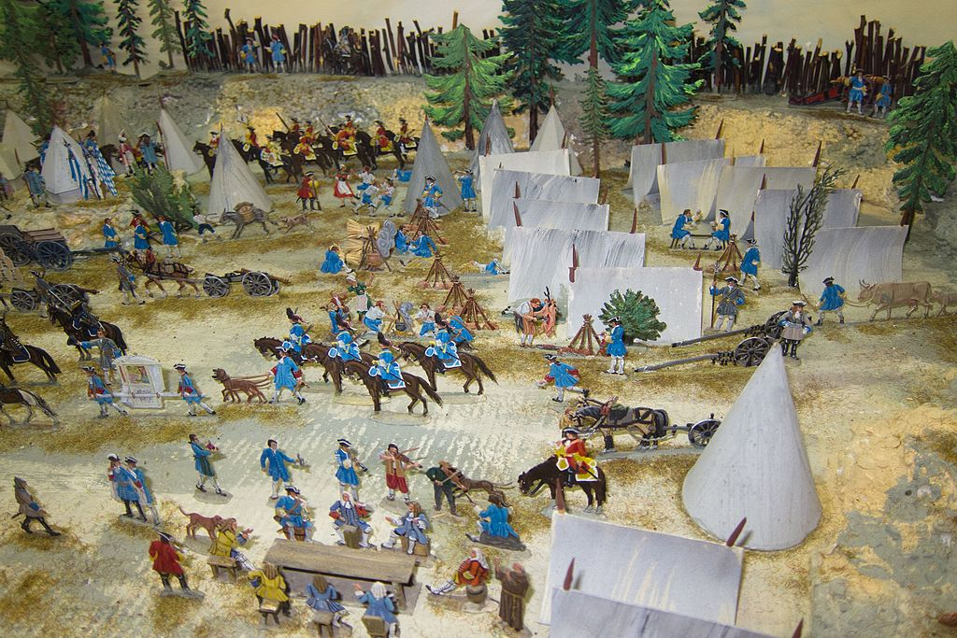
  3. Medieval Skybox
     1. 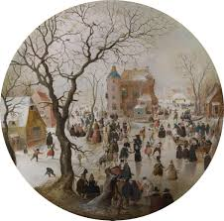
     2. 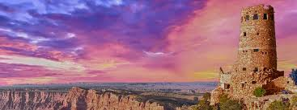
     3. 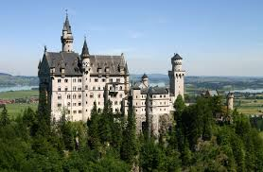
  4. Greenery
     1. 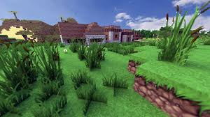
     2. 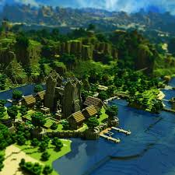
     3. 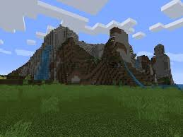
  5. Giant Brick Wall
     1. 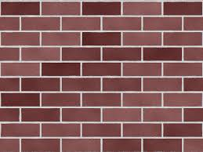
     2. 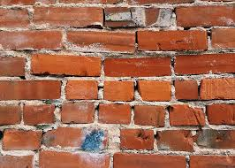

### Game Loop

* 1. Interaction for player with Humpty Dumpty
  2. Procedurally break the Humpty Dumpty model into many pieces
  3. Speak Recognition for player crying for help
  4. Game Mechanic for player to try to put Humpty back together
     1. Grid lines of where the pieces should all go
     2. Player clicks and drags them into the appropriate spot.
  5. Fading to black and restarting
  6. Hints to guide player towards the right areas

### Other Effects

* 1. Cartoon Lighting to make the experience feel more like Mother Goose
  2. Particle Effects to reward users for doing a correct actions
  3. Spatial Sound effects for egg breaking, king’s army marching, ambient sounds
  4. Procedural navigation mesh to have army walk around objects
  5. Light cues to make sure that players find where Humpty Dumpty is

Example Capstone Scoping

## Features And Dependencies:

### 3D Models + Animations

* 1. Humpty Dumpty model and animation
     1. **Revised: Will start with a basic Capsule model and then from there begin working on modeling and animating.**
  2. King’s army soldier
     1. **Revised: Will create one model and duplicate that to form an army in order to reduce scope.**
  3. Medieval Skybox
     1. **Revised: Will not be making this and will instead use the one provided by Unity.**
  4. Greenery
     1. **Revised: Will use SpeedTree to create the forest and save on performance and creation time.**
  5. Giant Brick Wall
     1. **Revised: Will use brick wall provided in this** [**Unity package**](https://www.assetstore.unity3d.com/en/#!/content/49581)

### Game Loop

* 1. Interaction for player with Humpty Dumpty
     1. **Still planning this!**
  2. ~~Procedurally break the Humpty Dumpty model into many pieces~~
     1. **Revised: procedural mesh destruction can be a little complicated, so instead we will just create a separate mesh that is destroyed.**
  3. Speak Recognition for player crying for help
     1. **Revised: although this is a bit complicated in scope, will do this for the Speech Recognition achievement.**
  4. ~~Game Mechanic for player to try to put Humpty back together~~
     1. ~~Grid lines of where the pieces should all go~~
     2. ~~Player clicks and drags them into the appropriate spot.~~
     3. **Revised: although a great mechanic to add interactivity, to scope down, I will remove the interactivity as it is inaccurate the storyline.**
  5. Fading to black and restarting
     1. **Revised: Still a go!**
  6. Hints to guide player towards the right areas
     1. **Revised: Will use baked lighting with light probes to avoid complexities and help performance as opposed to volumetric lights**

### Other Effects

* 1. Cartoon Lighting to make the experience feel more like Mother Goose
     1. **Revised: To scope down, will have to forgo this requirement**
  2. Particle Effects to reward users for doing a correct actions
     1. **Revised: Still planned to do.**
  3. Spatial Sound effects for egg breaking, king’s army marching, ambient sounds
     1. **Revised: Required as per the rubric, but will clearly increase the fidelity of the game**
  4. Procedural navigation mesh to have army walk around objects
     1. **Revised: Will use Unity Navigation to simplify this effect**
  5. Light cues to make sure that players find where Humpty Dumpty is
     1. **Revised: Relates to the guide players and this will be done with simple lighting (non volumetric)**